**Does the Intra-atomic Deformation Energy of IQA Represent Steric Energy?**

Benjamin C. B. Symons, Dominic Williamson, Campbell M. Brooks, Alex L. Wilson and Paul L. A. Popelier

Manchester Institute of Biotechnology (MIB), 131 Princess Street, Manchester M1 7DN, Great Britain and

School of Chemistry, University of Manchester, Oxford Road, Manchester M13 9PL, Great Britain

**Abstract**

In this work we show that the mutual, through-space compression of atomic volume experienced by approaching atoms causes an exponential increase in the intra-atomic energy of those atoms regardless of approach-orientation. This behaviour is consistent for all atoms except hydrogen which can behave differently depending on its environment. Whilst all atoms experience charge transfer when they interact, the intra-atomic energy of the hydrogen atom is found to be more vulnerable to these changes than larger atoms. The difference in behaviour is found to be due to hydrogen’s lack of a core of electrons which, in heavier atoms, consistently provides repulsion when compressed. As such, hydrogen atoms do not always provide steric hindrance. In accounting for hydrogen’s unusual behaviour and demonstrating the exponential character of the intra-atomic energy in all other atoms, we provide evidence for IQA’s intra-atomic energy as a quantitative description of steric energy.

1. **Introduction**
2. **Background and Methodology**

2.1 Repulsive Potential

Previous work[[1](#_ENREF_1)] established that repulsion in IQA is better represented by a Buckingham[[2](#_ENREF_2)] type potential as opposed to the widely used Lennard-Jones potential. This work will henceforth be referred to as paper A. As such our work will focus only on the Buckingham potential,

(1)

Equation 1 shows only the repulsive part of the potential as that is the term relevant to this work and is the equation used for all fits.

2.2 Interacting Quantum Atoms (IQA)

The Interacting Quantum Atoms (IQA) formalism[[3](#_ENREF_3)] is an energy partitioning scheme based on the Quantum Theory of Atoms in Molecules (QTAIM)[[4](#_ENREF_4)] wherein atoms are defined as topological features of the electron density of a system, derived from the wavefunction. Topological atoms have sharply-defined shapes and volumes that fill space with no gaps or overlap. In IQA, the total energy of a system is defined as the sum of the intra-atomic energies  and inter-atomic energies. Note that no assumptions are made about whether atoms are bonded or not in IQA as all atomic interactions are accounted for by.

Equation 2 demonstrates that the total energy of a system can be fully described as a sum of single-atom and pairwise energy contributions,

 (2)

where *n* is the number of atoms in the system. and  can be further decomposed into electrostatic and exchange-correlation terms. Since this work focuses on intra-atomic energies, we will not look further into the decomposition of inter-atomic energies. The intra-atomic energies can be broken down into Coulombic and kinetic energy contributions, as shown in Equation 3.

 (3)

 describes the interactions between the nucleus and electrons of a single atom, describes the interactions between electrons in that atom, and describes the kinetic energy of the electrons. The absolute values of these energy contributions represent the energy required or released in building an atom from isolated electrons and the nucleus, starting from infinite separation, and thus are of the order of hundreds of thousands of kJ mol-1 for a second-row element. It is therefore much more useful to measure changes in these contributions as the atom moves from one system to another, invoking the inherent transferability of topological atoms in IQA. In this paper, we investigate systems wherein two molecules are brought closer and closer together, resulting in compression in the volumes of the frontier atoms. This deformation of the frontier atoms is associated with an energy penalty described by, which is calculated by subtracting the intra-atomic energy of the atom in the free molecule from the intra-atomic energy of the atom in the system.

 (4)

The deformation of intra-atomic energy can be decomposed into deformations of,, and by subtracting the “free” value from the in-system value in the same fashion, for example as shown in Equation 5.

 (5)

The total repulsion of the two atoms is then represented as a sum of the deformations of their intra-atomic energies.

 (6)

This description of short-range repulsion as a deformation of intra-atomic energies, rather than an inter-atomic energy, is subtle but is important for characterising the interaction as steric. This interpretation is also not without precedent, as short-range steric repulsion and deformation are often used interchangeably.[[5-7](#_ENREF_5)] Note that while we adhere to the interpretation of steric energy laid out in Equation 6 we also regularly look at the two terms of Equation 6 separately in order to characterise the behaviour of individual atoms. This is necessary when looking at asymmetric systems in which the summing the deformation energies will result in the loss of information about the behaviour of the individual atoms. This being said, all fits performed are for the summed deformation energy as this is the physically meaningful short-range repulsion.

2.3 Computational Details

GAUSSIAN09[[8](#_ENREF_8)] was used to calculate optimised geometries for single molecules and generate wavefunctions for all molecules and systems at the B3LYP/aug-cc-pVTZ level of theory. IQA calculations were performed with version 17.11.14 of the program AIMALL[[9](#_ENREF_9)] to extract the intra-atomic energies and the contributing energies (*T*, *Vne,* and *Vee*). Volume and charge information were also calculated by AIMALL. In each experiment, the optimised “free” monomers were used as reference molecules and dimer systems at various separations were constructed using their geometries. Wavefunctions were then calculated for each system at each separation and analysed using AIMALL. The dimer systems were not re-optimised so as to better control the orientation of approach of the monomers.

Paper A investigated uncluttered approaches of atoms[[1](#_ENREF_1)], wherein molecules were brought together linearly to prevent unwanted interference of substituents with the atoms of interest. Using this methodology, an exponential relationship between separation and deformation energy was found in all cases. We sought to expand this model by including more diverse orientations of approach in N2, O2, F2, NH3, H2O, and HF dimers. To achieve this, we represented the two monomers in a polar coordinate system and defined an initial orientation as a staggered conformation with respect to the hydrogen atoms where the two heavy atoms faced each other. The relative orientation of the molecules was altered by moving one of the molecules to vary the polar angle ‘theta’ () from to in increments of . We will hereafter call this a “theta scan”. We then brought the molecules together by decreasing the internuclear separation of the main-group atoms (i.e. N, O, or F). A schematic of this is shown in Figure 1.

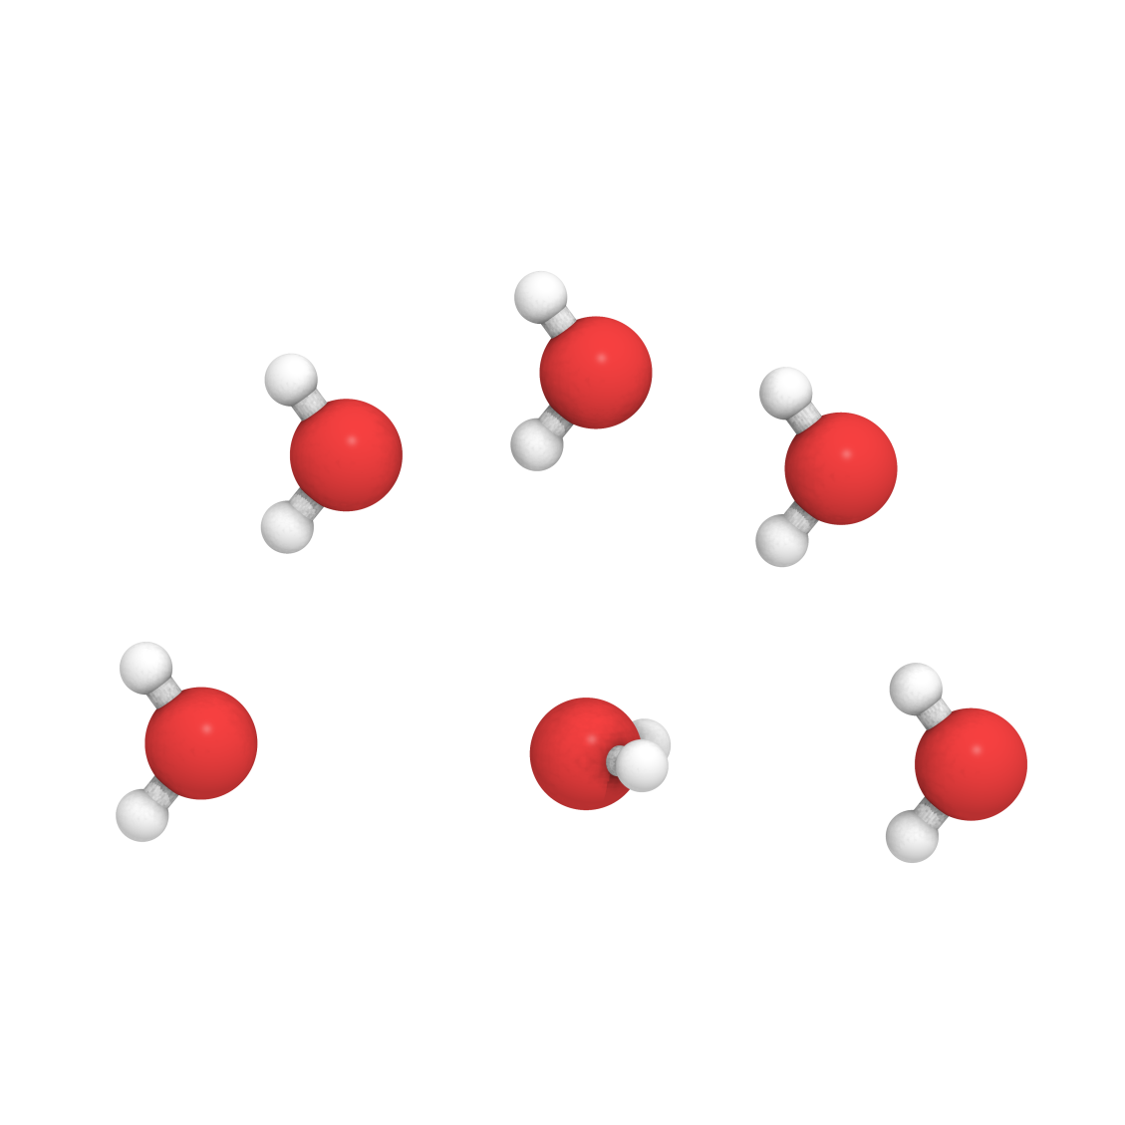

**Figure 1.** Orientations of optimised water molecule pairs in an exemplar theta scan experiment. In each experiment, one water molecule approaches the central molecule along the coordinate indicated by an arrow.

The results of the theta scan experiments raised questions about the behaviour of hydrogen atoms in different environments, so we designed new experiments to categorise and explain our observations. In these experiments, a hydrogen atom in one molecule was made to approach an atom in another molecule in a linear fashion. These experiments are split into two categories; hydrogen-X approaches and hydrogen-hydrogen approaches which are demonstrated in Figures 2a and 2b respectively. Substituents were positioned so as to maximise the distance between them and the approaching atoms and thus minimise their influence.

|  |  |
| --- | --- |
|  |  |

**Fig. 2** (a) Iris visualisation of the H2O dimer in the linear H-O approach. (b) Iris visualisation of the H2O dimer in the linear H-H approach.

We varied the environment of the hydrogen atom by changing the atoms to which hydrogen was bonded and which it was approaching. For example, a hydrogen atom bears a positive charge when bonded to a nitrogen atom but is neutral when bonded to a carbon atom. As is discussed later, the charge of the hydrogen atom has a significant effect on the behaviour of its intra-atomic energy. We focus predominantly on second row elements in this paper but a full list of systems studied, which includes third row elements also, can be found in the supporting information.

As an extension to these experiments, we performed a selection of them again but this time allowing the geometries of the molecules to partially re-optimise during the approach. We fixed the minimum number of coordinates to preserve the approach orientation but allowed the internal coordinates of each molecule to vary. In practice this meant fixing the bond length between approaching atoms at each separation as well as fixing some dihedral angles. Using this method we did a theta scan for HF in which bond lengths were allowed to change and hydrogen-hydrogen and hydrogen-X experiments with H2O and NH3 in which both bond lengths and internal bond angles were allowed to vary.

IQA-calculated atomic volumes are bounded, if not by an interatomic surface, by an equipotential of electron density at a certain value, for example 0.001 a.u.. The atomic volumes are therefore a measure of the size of an atom’s electron cloud and are element-dependent. The repulsion experienced between two atoms should depend on the distance between their electron clouds rather than their nuclei, so it is practical to compare systems with atoms at separations relative to the size of their electron clouds. The reasoning behind this is detailed in paper A[[1](#_ENREF_1)]. We used Bondi’s elemental van der Waals radii[[10](#_ENREF_10)] as surrogates for the size of atomic electron clouds. We begin with internuclear separation of the atoms of interest equal to 130% the sum of their van der Waals radii. We then decreased the separation to 70% in increments of 4%.

The upper separation limit was chosen as the trends in the data were well established below this limit. Extrapolating from our data it is evident that, above 130% of the sum of the van der Waals radii, all IQA energy contributions tend towards their values in the reference molecule. The lower limit was chosen as at close separations, substituent hydrogen atoms begin to interact more with the atoms of interest and the interaction energy of the atoms of interest are no longer isolable. This is especially true for more sterically crowded systems such as the NH3 dimer.

1. **Results**

3.1 Theta Scan

For each theta increment we fitted a Buckingham potential to the sum of the deformation energies of the 2 heavy atoms. Details of the fits for the HF dimer are shown in Table 1, information for the other dimers studied is provided in the supporting information in Tables S1-S6.

|  |  |  |  |  |  |  |
| --- | --- | --- | --- | --- | --- | --- |
| **Theta** | **RMS Error** | **Energy Range** | **Minimum Energy** | **Maximum Energy** | **Coefficient A** | **Coefficient B** |
| 0 | 1.9 | 147.4 | 4.5 | 151.9 | 22,194 | 2.4299 |
| 10 | 1.9 | 148.9 | 4.4 | 153.3 | 22,841 | 2.4393 |
| 20 | 1.9 | 153.2 | 4.3 | 157.5 | 24,520 | 2.4604 |
| 30 | 1.8 | 160.1 | 4.1 | 164.2 | 26,693 | 2.4810 |
| 40 | 1.6 | 168.7 | 3.8 | 172.5 | 29,010 | 2.4967 |
| 50 | 1.3 | 177.8 | 3.4 | 181.3 | 31,321 | 2.5088 |
| 60 | 1.0 | 186.3 | 3.0 | 189.3 | 33,936 | 2.5258 |
| 70 | 0.8 | 193.4 | 2.4 | 195.8 | 37,222 | 2.5533 |
| 80 | 0.6 | 199.1 | 1.8 | 201.0 | 41,176 | 2.5888 |
| 90 | 0.5 | 205.2 | 1.4 | 206.6 | 45,373 | 2.6218 |
| 100 | 0.5 | 214.4 | 1.3 | 215.7 | 48,432 | 2.6321 |
| 110 | 0.5 | 230.2 | 1.9 | 232.0 | 48,766 | 2.6005 |
| 120 | 0.9 | 255.4 | 3.3 | 258.7 | 45,998 | 2.5204 |
| 130 | 1.5 | 293.5 | 5.6 | 299.2 | 42,918 | 2.4164 |
| 140 | 1.7 | 347.5 | 8.1 | 355.6 | 42,680 | 2.3291 |
| 150 | 2.1 | 427.1 | 9.1 | 436.1 | 63,271 | 2.4174 |
| 160 | 3.6 | 405.5 | 7.8 | 413.3 | 99,405 | 2.6662 |
| 170 | 2.4 | 9.1 | 5.7 | 14.8 | 74 | 0.5811 |
| 180 | 5.0 | 41.8 | -37.7 | 4.0 | -14,673,600 | 5.3069 |

**Table 1.** All of the relevant information for the HF dimer theta scan. Absolute root-mean-square (rms) errors in kJ/mol for the fits from for the sum of the deformation energies of the main group atoms. The minimum, maximum and range of energies in kJ/mol are provided to give context to the absolute rms errors. Provided also are the fit coefficients.

The absolute rms errors for the fits in Table 1 are all low but, when considering them in the context of the energy ranges it is evident that the quality of fits deteriorates at the largest values of . For example, at , the rms error is 26.4% of the energy range. It is therefore pertinent here to ask whether atoms separated by substituents, such as the heavy atoms at , can be considered to be sterically interacting. We define a steric interaction as a mutual compression of atomic volumes that occurs through-space. Figure 3a shows that at for the HF dimer, there is no through-space compression of the fluorine atomic volumes. This accounts for the worse fits for HF at the largest theta values as there is clearly no steric interaction between the fluorine atoms. In contrast, the fits for all other dimers examined remain of good quality throughout the theta scan, as evidenced in the supporting information. Visualisation shows that for water and ammonia at there is still a significant portion of “bare” electron density between the hydrogen atoms that can interact through-space. An example of this is shown in Figure 3b. As a result, we have no problem characterising this as a steric interaction, though it is likely perturbed by interactions with the hydrogen atoms. Overall these fits demonstrate that IQA recovers a Buckingham type potential without any problems, not just for the most basic (and unrealistic) of approaches but for a wide range of approaches.

|  |  |
| --- | --- |
| HF_160_10 | ATT45958 |

**Fig. 3** (a) Iris visualisation of the HF dimer at . This demonstrates the lack of compression of the atomic volumes of the fluorine atoms. (b) Iris visualisation of the NH3 dimer at . This demonstrates the compression of the atomic volumes of the nitrogen atoms.

We also looked at the decomposition of the intra-atomic energy into its constituent terms, Vne, Vee, and T. An example characteristic of a pure volume compression is shown in Figure 4a. The behaviour of the energy contributions is as expected. T becomes more positive as electrons are progressively confined thus increasing their momentum as required by the uncertainty principle. Vee becomes increasingly positive as electrons are on average closer together so experience greater repulsion. Vne becomes increasingly negative as electrons are on average closer to the nucleus so experience greater attraction. We also see that Vne and Vee are approximately equal and opposite, so the intra-atomic energy is dominated by the kinetic energy term.

On the other hand, Figure 4b shows a similar plot for the nitrogen atoms in the NH3 dimer at . Here the Vee and Vne terms can no longer be explained by only considering a volume compression. The nitrogen atoms become more positive during the scan; this is in contrast to the N2 nitrogen atoms in Figure 4a which are neutral due to the symmetry of the system. From this transfer of charge we expect that Vne will become more positive as the electron-nuclear attraction is reduced and Vee will become less positive as electron-electron repulsion is reduced. As such it is evident that, at the largest separations, the trends in Vne and Vee are consistent with a charge transfer. As the separation decreases below 0.9 the van der Waals radius, the trends switch direction suggesting that volume compression effects take over the behaviour.

In spite of the nuances in the behaviour of Vne and Vee, the intra-atomic energy is exponential in both Figures 4a and 4b. This is because Vne and Vee mostly cancel each other out leaving the kinetic energy to dominate the intra-atomic energy. As such we conclude that charge transfer effects are not of great importance for heavy atoms.

|  |  |
| --- | --- |
|  |  |
|  |  |

**Fig.4** (a) Decomposed intra-atomic energy for the nitrogen atoms at in the N2 dimer theta scan. (b) Decomposed intra-atomic energy for the nitrogen atoms at in the NH3 dimer theta scan.

Inspection of the plots of the deformation energy of hydrogen and its contributing terms discovered behaviour that deviated significantly from the volume-compression model, wherein the deformation energy was often negative. This behaviour was more rigorously investigated in the linear dimer experiments.

3.2 Hydrogen-X Approaches

For all hydrogen-X approaches tested, the sum of the deformation energies of the approaching atoms was well represented by an exponential function. The rms errors displayed in Table 2 are all within an acceptable range given the scale of the energies. Further fit details for all of the systems studied can be found in Table S7 in the supporting information.

|  |  |  |  |  |  |
| --- | --- | --- | --- | --- | --- |
| **System** | **RMS Error** | **System** | **RMS Error** | **System** | **RMS Error** |
| NH3-NH3 | 2.7 | FH-FH | 1.1 | OH2-OH2 | 2.5 |
| NH3-OH2 | 2.5 | FH-OH2 | 6.1 | OH2-NH3 | 2.7 |
| NH3-FH | 1.8 | FH-NH3 | 1.9 | OH2-FH | 1.8 |

**Table 2.** Rms errors in kJ/mol for the exponential fits for some of the hydrogen-X approaches studied.

The series of approaches in Table 3 provide some insight into the potential physical meaning of the fit coefficients A and B. Mathematically speaking, A sets the scale of the plot and B sets the gradient. As such it would make sense for B, the gradient, to correspond to the ‘hardness’ of an atom as the gradient here gives a measure of the energy penalty incurred as the electron cloud is deformed. The harder an atom is, the greater the expected energy penalty. The trend in B shown in Table 3 supports this idea as B, and so the gradient of the intra-atomic energy, increases from N to F. This would suggest that nitrogen is the ‘softest’ of the three atoms and fluorine the ‘hardest’ which is in agreement with chemical intuition and the literature[[11-13](#_ENREF_11)]. This trend is seen more than once in our work and further details are shown in the supporting information in Table S7. This is somewhat speculative at this point and could form the basis of future work.

|  |  |  |  |  |  |  |
| --- | --- | --- | --- | --- | --- | --- |
| **System** | **RMS Error** | **Energy Range** | **Minimum Energy** | **Maximum Energy** | **Coefficient A** | **Coefficient B** |
| CH4-NH3 | 1.4 | 133.9 | 9.4 | 143.3 | 4,579 | 1.80705 |
| CH4-OH2 | 1.3 | 111.2 | 7.1 | 118.3 | 4,457 | 1.91439 |
| CH4-FH | 1.1 | 81.6 | 4.5 | 86.1 | 4,460 | 2.12162 |

**Table 3.** Complete fit details for a series of H-X experiments in which a CH4 hydrogen atom approaches nitrogen, oxygen and fluorine atoms.

Whilst the fits in Tables 2 and 3 are all of good quality, when the intra-atomic energies of each individual atom are decomposed into Vne, Vee, and T, it is clear that the dominant effects governing the behaviour of the hydrogen atom and the heavy atom energy contributions are different. The energy contributions displayed for nitrogen in Figure 5a are consistent with a volume compression as shown in Figure 4a, and the intra-atomic energy is dominated by kinetic energy. While the intra-atomic energy of hydrogen in Figure 5b is still positive and exponential, the kinetic energy is negative and the dominant term is now Vne.

|  |  |
| --- | --- |
|  |  |

**Fig.5** (a) Decomposed intra-atomic energy for the nitrogen in a NH3 dimer hydrogen-nitrogen approach. (b) Decomposed intra-atomic energy for the hydrogen in a NH3 dimer hydrogen-nitrogen approach.

The hydrogen atom becomes increasingly positive during the approach, as shown in Figure 6. This means the average number of electrons in the atomic volume decreases. We therefore expect that T will become more negative as there are fewer electrons to add to the total kinetic energy. Vne and Vee are also expected to behave as explained above in reference to Figure 4b. These expectations are met but, in this case (as opposed to the case in Figure 4b) the trends are consistent throughout the scan suggesting that this is characteristic entirely of a charge transfer despite the compression of atomic volume.

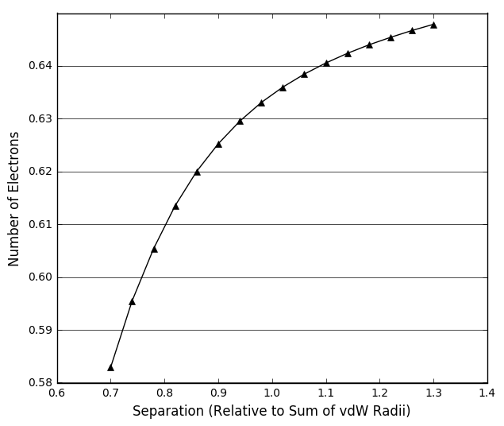

**Fig. 6** The change in the number of electrons (base electrons minus net atomic charge) for the hydrogen in the NH3 dimer hydrogen-nitrogen approach.

3.3 Hydrogen-Hydrogen Approaches

To further investigate the behaviour of hydrogen we looked at a hydrogen approaching hydrogen in various dimers. An example of the energy contributions for one of the interacting hydrogen atoms in the NH3 dimer is shown below in Figure 7a.

|  |  |
| --- | --- |
|  |  |

**Fig.7** (a) Decomposed intra-atomic energy for a hydrogen atom in a NH3 dimer hydrogen-hydrogen approach. (b) Change in number of electrons for a hydrogen atom in a NH3 dimer hydrogen-hydrogen approach.

Figure 7a demonstrates trends in the energy contributions that are characteristic of a volume compression. As shown in Figure 7b, the atom also gains 0.015 electrons as the separation is decreased which reinforces the effects of compression on the energy contributions. This is the reverse of what is seen in Figure 5b where the volume and charge effects are in opposition. In contrast to other atoms in which behaviour is dominated by volume compression, the Vne contribution is of sufficient magnitude to cancel out the T and Vee contributions resulting in a near-zero intra-atomic energy. Figures 8a and 8b show the same approach for H2O. Here there is a gain of about 0.027 electrons during the scan which is a greater change than in the NH3 system meaning the Vne contribution is larger relative to T and Vee and therefore the intra-atomic energy is decidedly negative. Although this does not match the repulsive nature of a steric interaction, it is not uncommon in the literature to assume that hydroxyl and amine[[14](#_ENREF_14)] hydrogen atoms provide no steric hindrance. For example, in many water models [[15-21](#_ENREF_15)] a zero collision diameter is assigned to the Lennard-Jones potential for hydrogen atoms.

|  |  |
| --- | --- |
|  |  |

**Fig.8** (a) Decomposed intra-atomic energy for a hydrogen atom in a H2O dimer hydrogen-hydrogen approach. (b) Change in number of electrons for a hydrogen atom in a H2O dimer hydrogen-hydrogen approach.

|  |  |
| --- | --- |
|  |  |

**Fig.9** (a) Decomposed intra-atomic energy for a hydrogen atom in a CH4 dimer hydrogen-hydrogen approach. (b) Change in number of electrons for a hydrogen atom in a CH4 dimer hydrogen-hydrogen approach.

In CH4, the hydrogen atom is essentially neutral and undergoes a very small change in charge during the experiment as shown in Figure 9b. The magnitude of Vne is therefore not largely affected, and the trends in the energy contributions shown in Figure 9a are consistent with a typical volume compression. Specifically, it is now T that dominates the intra-atomic energy because Vne and Vee mostly cancel each other out.

We have now observed a spectrum of different hydrogen behaviours that demonstrate how each of the energy contributions responds differently to changes in volume and charge. The kinetic energy is influenced significantly by volume but is relatively resistant to changes in atomic charge. The increasing confinement of electrons during a compression inevitably increases their kinetic energy as a result of the uncertainty principle. This increase will not be greatly affected by the loss of electrons provided there is a sufficient base population of electrons being compressed. Vne and Vee however, are naturally predominantly dependent on charge as they both have significant Coulombic contributions. However, Vne and Vee will be affected somewhat by volume compression as the average electron-nuclear and electron-electron distances decrease. Generally there is an inverse symmetry in the behaviour of Vne and Vee, which results in a large degree of cancellation when summed. However, they do not perfectly cancel each other out as Vee is typically more vulnerable to charge transfer than Vne­. We believe that this is because Vee is purely electron dependent whereas Vne also depends on the nuclear charge, which is a fixed quantity. The lack of cancellation can lead to Vne dominating the intra-atomic energy at lower electron populations when the kinetic energy is not of sufficient magnitude to compensate for the difference between Vne and Vee.

The evidence for this model is best demonstrated by further examining the H2O and CH4 dimers, which exhibit the extremes of hydrogen behaviour. In Figure 8a, the H2O dimer, the hydrogen intra-atomic energy is clearly dominated by Vne whereas in Figure 9a, the CH4 dimer, it is dominated by kinetic energy. We explain this difference in behaviour by considering that hydrogen’s electron density is provided entirely by valence electrons. This makes hydrogen far more vulnerable than heavier atoms to changes in atomic charge. In CH4, the hydrogen begins with a charge of -0.006e which means it has 1.006 electrons. We can see from Figure 9b that the number of electrons decreases by about 0.005. Given this is only a minor effect and that hydrogen still has sufficient electron density, the compression of volume results in a positive deformation of the kinetic energy. This is contrasted with the hydrogen atom in H2O which is positive and begins with a charge of +0.56e meaning it has 0.44 electrons. Figure 8b shows that this hydrogen gains about 0.03 electrons. This is a much greater change than in the CH4 case which, coupled with the fact that the hydrogen begins with a smaller electron density, means that the magnitudes of the Vee and T are significantly reduced relative to Vne.

The model presented here applies not only to hydrogen but also to heavier atoms. In contrast to hydrogen, heavy atoms have a larger population of electrons because they have a core of electrons. This means that they are not so affected by the gain or loss of valence electrons as, despite these fluctuations, the core electron density will behave consistently under compression. As such, the kinetic energy is always sufficiently positive that it dominates the intra-atomic energy despite the incomplete cancellation of Vne and Vee. This means that the intra-atomic energy is always well represented by a Buckingham type potential in a steric interaction.

In addition to the experiments presented so far, we performed some relaxed experiments in which partial re-optimisation of the geometries was allowed during the approaches. Comparison of Figures 10a and 5a shows that for the same experiment, allowing partial re-optimisation does not have any effect on the trends in the energy contributions. Furthermore, Figure 10b demonstrates that the absolute deviations in the intra-atomic energy for both the nitrogen and hydrogen atom in the scan are relatively small, only becoming significant at the smallest separations. This suggests that our model still holds when molecules are allowed to relax which is promising as this scenario is closer to reality. Note that further evidence relating to these experiments can be found in section 4 of the supporting information.

|  |  |
| --- | --- |
|  |  |

**Fig.10** (a) Decomposed intra-atomic energy for the nitrogen atom in a relaxed NH3 dimer hydrogen-nitrogen approach. (b) Intra-atomic energy deviations from the equivalent rigid experiment shown in Figure 5a. The Deviation is calculated as relaxed-rigid.

1. **Conclusion**

In conclusion, we have specified that for two atoms to be sterically interacting, they must experience a mutual, through-space compression of atomic volume. This can occur in a wide range of approach orientations even when smaller substituents clutter the line of approach. We have shown that the deformation of the IQA intra-atomic energy is responsible for stereoelectronic effects. When the intra-atomic energy is decomposed it is evident that these effects are produced by the interplay between T, Vne and Vee. T responds predominantly to volume deformation and so it appears to be the main contributor to the steric effects, whereas Vne and Vee respond far more strongly to charge transfer and so appear to comprise the main contribution to the electronic effects.

We have observed that this interplay of energy contributions is similar for all heavy atoms across all situations, provided there is volume compression. The interplay of energy terms for hydrogen atoms however, is not constant across different situations. This is because hydrogen is more sensitive to changes in atomic charge as its electron density is provided entirely by valence electrons. As such, hydrogen’s intra-atomic energy is not necessarily well represented by a Buckingham potential and so hydrogen does not reliably produce steric hindrance. This is a finding that is not completely surprising as it has been used as an assumption in other areas of computational chemistry, for example in parameterised water models.

**Acknowledgments**

The EPSRC is thanked for the award of an Established Career Fellowship (grant EP/K005472).

**References**

1. Wilson, A.L. and P.L.A. Popelier, *Exponential relationships capturing atomistic short-range repulsion from the Interacting Quantum Atoms (IQA) method* J.Phys.Chem.A, 2016. **120**: p. 9647-9659.

2. Buckingham, R.A., *The Classical Equation of State of Gaseous Helium, Neon and Argon.* Proc.Roy.Soc.A, 1938. **168**: p. 264-283.

3. Blanco, M.A., A. Martín Pendás, and E. Francisco, *Interacting quantum atoms: a correlated energy decomposition scheme based on the quantum theory of atoms in molecules.* J.Chem.Theor.Comput., 2005. **1**: p. 1096-1109.

4. Bader, R.F.W., *Atoms in Molecules. A Quantum Theory.* 1990, Oxford, Great Britain: Oxford Univ. Press.

5. Kong, C.L., *Atomic distortion and the repulsive interactions of the noble gas atoms.* J.Chem.Phys., 1973. **59**(2): p. 968-969.

6. Smith, F.T., *Atomic Distortion and the Combining Rule for Repulsive Potentials.* Physical Review A, 1972. **5**(4): p. 1708-1713.

7. Dillen , J., *Congested Molecules. Where is the Steric Repulsion? An Analysis of the Electron Density by the Method of Interacting Quantum Atoms.* Int.J.Quant.Chem., 2013. **113**: p. 2143–2153.

8. GAUSSIAN09 Revision B.01, M. J. Frisch, G. W. Trucks, H. B. Schlegel, G. E. Scuseria, M. A. Robb, J. R. Cheeseman, G. Scalmani, V. Barone, B. Mennucci, G. A. Petersson, H. Nakatsuji, M. Caricato, X. Li, H. P. Hratchian, A. F. Izmaylov, J. Bloino, G. Zheng, J. L. Sonnenberg, M. Hada, M. Ehara, K. Toyota, R. Fukuda, J. Hasegawa, M. Ishida, T. Nakajima, Y. Honda, O. Kitao, H. Nakai, T. Vreven, J. A. Montgomery, Jr., J. E. Peralta, F. Ogliaro, M. Bearpark, J. J. Heyd, E. Brothers, K. N. Kudin, V. N. Staroverov, R. Kobayashi, J. Normand, K. Raghavachari, A. Rendell, J. C. Burant, S. S. Iyengar, J. Tomasi, M. Cossi, N. Rega, J. M. Millam, M. Klene, J. E. Knox, J. B. Cross, V. Bakken, C. Adamo, J. Jaramillo, R. Gomperts, R. E. Stratmann, O. Yazyev, A. J. Austin, R. Cammi, C. Pomelli, J. W. Ochterski, R. L. Martin, K. Morokuma, V. G. Zakrzewski, G. A. Voth, P. Salvador, J. J. Dannenberg, S. Dapprich, A. D. Daniels, Ö. Farkas, J. B. Foresman, J. V. Ortiz, J. Cioslowski, and D. J. Fox, Gaussian, Inc., Wallingford CT, USA, 2009., *GAUSSIAN09*. 2009.

9. Keith, T., *AIMAll*. 2017, TK Gristmill Software: Overland Park, KS, USA.

10. Bondi, A., *Van der Waals volumes and radii.* J.Phys.Chem., 1964. **68**: p. 441-451.

11. Parr, R.G. and R.G. Pearson, *Absolute Hardness - Companion Parameter to Absolute Electronegativity.* J.Am.Chem.Soc., 1983. **105**(26): p. 7512-7516.

12. Baumer, L., Sala, G. and Sello, G., *A new method for the calculation of atomic and local hardness.* Journal of Computational Chemistry, 1990. **11**(6): p. 694-699.

13. Komorowski, L., *Electronegativity and hardness in the chemical approximation.* Chemical Physics, 1987. **114**(1): p. 55-71.

14. Hagler, A., E. Huler, and S. Lifson, *Energy functions for peptides and proteins. I. Derivation of a consistent force field including the hydrogen bond from amide crystals.* Journal of the American Chemical Society, 1974. **96**(17): p. 5319-5327.

15. Berendsen, H.J.C., J.R. Grigera, and T.P. Straatsma, *(SPC/E) The Missing Term in the Effective Pair Potentials.* J.Phys.Chem., 1987. **91**: p. 6269-6271.

16. Berendsen, H.J.C., et al., *Interaction Models for Water in Relation to Protein Hydration*. Intermolecular Forces, ed. B. Pullman. 1981, Dordrecht: Reidel. 331-342.

17. Mark, P. and L. Nilsson, *Structure and dynamics of the TIP3P, SPC, and SPC/E water models at 298 K.* The Journal of Physical Chemistry A, 2001. **105**(43): p. 9954-9960.

18. Zhu, S., et al., *A flexible/polarizable simple point charge water model.* The Journal of Physical Chemistry, 1991. **95**(16): p. 6211-6217.

19. Mahoney, M.W. and W.L. Jorgensen, *A five-site model for liquid water and the reproduction of the density anomaly by rigid, nonpolarizable potential functions.* J Chem.Phys., 2000. **112**: p. 8910-8922.

20. Abascal, J.L.F. and C. Vega, *A General Purpose Model for the Condensed Phases of Water: TIP4P/2005.* Journal of Chemical Physics 2005 **123**.

21. Price, D.J. and C.L. Brooks III, *A modified TIP3P water potential for simulation with Ewald summation.* The Journal of chemical physics, 2004. **121**(20): p. 10096-10103.